 | TT Rock Stars | Maths  Oak Academy | English  Oak Academy | Wider Curriculum  Oak Academy | Study Ladder  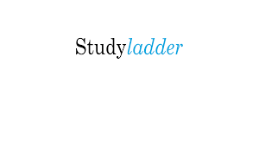 | Spellings  Reading  Projects
Monday | TTRockstars | Addition | Reading | Art | Studyladder | Please recap the spellings from last half term
Tuesday | TTRockstars | Subtraction | Reading | Art | Studyladder | Please recap the spellings from last half term
Wednesday | TTRockstars | Addition with rounding | Reading | Art | Studyladder | Please recap the spellings from last half term
Thursday | TTRockstars | Subtraction with rounding | Reading | Art | Studyladder | Please recap the spellings from last half term
Friday | TTRockstars | Adding 2 3-digit numbers | Reading | Art | Studyladder | Please recap the spellings from last half term

